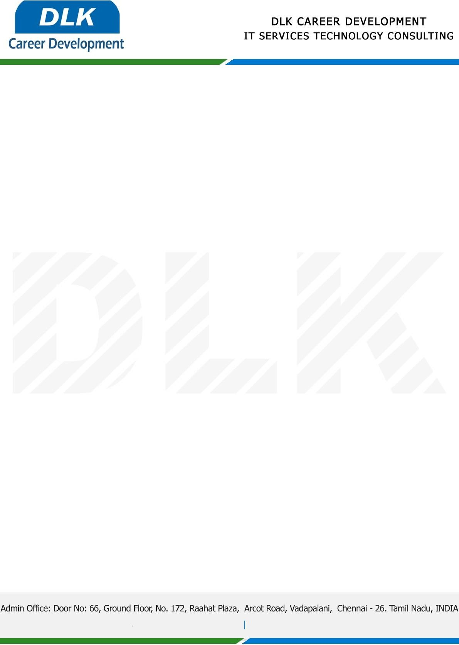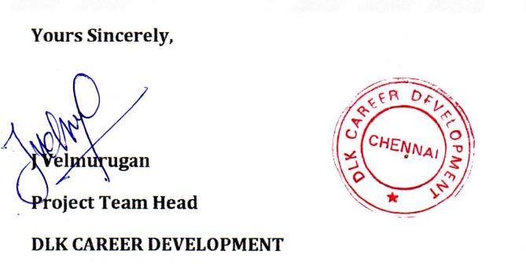

Date: 02 / December/ 2022

**To**

Department of BSC ([Computer Science),](https://www.cseindia.org/) Head of Department,

Shri Krishnaswamy College for Women, Chennai - 600040 .

# Sub: Letter of Project Acceptance

This is to certify that **MS PRIYA T (REG NO: 832100619)** final year student of has accepted the Project Work duration from **December 2022 to May 2023** under the domain **“Cyber Security”.** During the Project, all information and data collected from you should be kept confidential.

Topic: Credential Manager Application With Encrypt and Decrypt File Management.

We appreciate your interest in **DLK CAREER DEVELOPMENT**